**Lab Assignment 2**

|  |  |
| --- | --- |
| **Roll No.:** A055 | **Name:** Ibrahim Shaikh |
| **Program:** B. Tech-CSBS (2ND YEAR) | **Date of Release:** 26-July-2021 |
| **Batch:**  A/1 | **Date of Submission:** 1-August-2021 |

**PROBLEM STATEMENT:**

**Problem Statement 1:** User would like to add two numbers of different types such as short, int, float, double, long double, long int, char. System accepts the numbers and depending on its type appropriate function would be invoked. Display the result of addition.

**Problem Statement 2:** Write a program to calculate total “Volume” of different measure (Shapes) such as **cube, sphere, cylinder and cone**. Write separate functions for each shape and return their volume to main for total calculation. Display total volume in main function.

**Problem Statement 3:** Enter the marks of the students and display highest and lowest marks of the class. Apply ‘Max’ and ‘Min’ functions to find out the maximum value and minimum value from the list of elements. Pass an array by reference to ‘Max’ and ‘Min’ function from main. Display maximum and minimum values in main function.

**Concept to be implemented**: Function overloading, Call by reference with an array.

**CODE:**

**Answer for Problem Statement 1:**

#include<iostream>

using namespace std;

int add(int a, int b)

{

    return a + b;

}

float add(float a, float b)

{

    return a + b;

}

int add(int a, float b)

{

    return a + b;

}

double add(double a, double b)

{

    return a + b;

}

int main()

{

    double x,y,sum;

    cout<<"Enter the two numbers you want to add: ";

    cin>>x>>y;

    sum = add(x,y);

    cout<<"The sum is: "<<sum;

    return 0;

}

**Answer** **for** **Problem Statement 2:**

#include <iostream>

using namespace std;

void cube()

{

    int a;

    float vol;

    cout<<"Enter the side of the cube: ";

    cin>>a;

    vol = a*a*a;

    cout<<"The Volume is: "<< vol<<"\n";

}

void cylinder()

{

    float vol;

    int a, b;

    cout<<"Enter the radius of the cylinder: ";

    cin>>a;

    cout<<"Enter the height of the cylinder: ";

    cin>>b;

    vol = (22*a *a *b/7);

    cout<<"The Volume is: "<< vol;

}

void sphere()

{

    int r;

    float vol;

    cout<<"Enter the radius of the sphere: ";

    cin>>r;

    vol = (4*3.14*r*r*r/3);

    cout<<"The Volume is: "<< vol<<"\n";

}

void cone()

{

    float vol;

    int a, b;

    cout<<"Enter the radius of the cone: ";

    cin>>a;

    cout<<"Enter the height of the cone: ";

    cin>>b;

    vol = (22*a*a*b/21);

    cout<<"The Volume is: "<< vol;

}

int main()

{

    int opt;

    cout<<"Select the shape of which you need to find the volume\n";

    cout<<"1. CUBE\n2. SPHERE\n3. CYLINDER\n4. CONE\n ";

    cout<<"\nEnter your choice: ";

    cin>>opt;

    switch(opt)

    {

        case 1: cube();

                break;

        case 2: sphere();

                break;

        case 3: cylinder();

                break;

        case 4: cone();

                break;

        default: cout<<"\nThe entered option is INCORRECT!!!\n";

    }

    return 0;

}

**Answer for Problem Statement 3:**

#include<iostream>

using namespace std;

void Max (int a[], int n)

{

    int m;

    m = a[0];

    for(int i=1; i<n; i++)

    {

    if (a[i]> m)

        {

            m = a[i];

        }

    }

    cout<<"\nMaximum Marks is: "<<m<<"\n";

}

void Min (int a[], int n)

{

    int m;

    for(int i=1; i<n; i++)

    {

        if (a[i]< m)

        {

            m = a[i];

        }

    }

    cout<<"Minimum Marks is: "<<m;

}

int main()

{

    int marks[50], x, i;

    cout<<"Enter the Number of Students' Marks you want: ";

    cin>>x;

    cout<<"Enter the marks of "<<x<<" students: ";

    for(i=0; i<x; i++)

    {

        cin>>marks[i];

    }

    Max(marks, x);

    Min(marks, x);

}

**OUTPUT:**

**Output for Problem Statement 1:**

1. **int and float**



1. **int and int**



1. **float and float**



**Output for Problem Statement 2:**

1. **Incorrect Option**

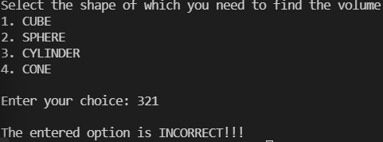

1. **Cube**

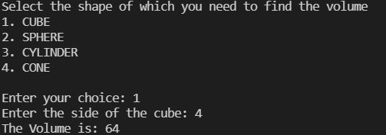

1. **Sphere**

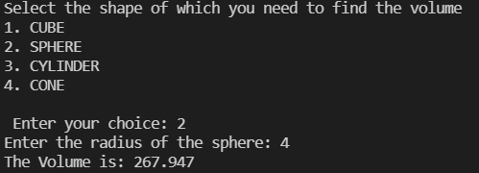

1. **Cylinder**

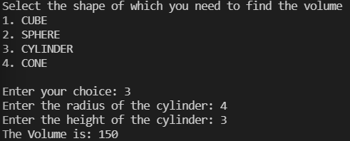

1. **Cone**

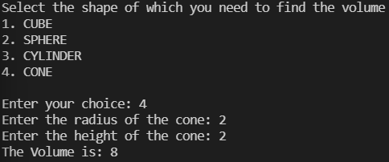

**Output for Problem Statement 3:**

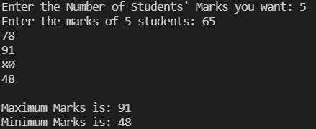

**LINK FOR THE CODE:** Done using VSCode